|  |  |
| --- | --- |
|  |  |
| DT Report |  |
|  |  |
|  | 18th February 2025.Government hospitals in India |
|  | Team DisorderProf. Hari Sharan Dwivedi |

# Introduction

India's public healthcare system plays a crucial role in providing affordable and accessible medical services to millions of people. However, government hospitals often face numerous challenges, including overcrowding, inefficient patient management, long waiting times, and a lack of streamlined communication between healthcare professionals. These issues not only hinder the quality of patient care but also place immense pressure on hospital staff.

To address these challenges, we have developed a **comprehensive digital platform** designed to serve as a **centralized hub for government hospitals across India**. This app leverages technology to enhance hospital operations, improve communication, and provide seamless access to essential healthcare services.

The platform is built with three primary user profiles—**patients, nurses, and doctors**—each offering tailored functionalities:

* **Patients** can book appointments, receive real-time updates, access their digital health records, and communicate with healthcare professionals, reducing unnecessary hospital visits and wait times.
* **Nurses** have access to shift management tools, real-time patient updates, and hospital announcements, enabling them to work more efficiently and deliver better care.
* **Doctors** can manage patient consultations, review medical histories, and collaborate with hospital staff to ensure smooth hospital operations.

By integrating all key stakeholders within a single digital ecosystem, this app aims to **bridge the gap between patients and healthcare providers, optimize hospital workflows, and enhance the overall efficiency of government hospitals**. With a user-friendly interface and a focus on accessibility, this initiative represents a step toward **modernizing India’s public healthcare system and ensuring quality medical services for all**.

# Index

Table of Contents

Introduction 2

Index 3

Team 4

Identified Problem 11

Primary Research 12

Secondary Research 16

Stakeholder Map 18

Description and elaboration 18

Identifying Creators and Victims 19

The Map 21

Why Web 23

Description and elaboration 23

Root Cause Analysis 25

The Map 26

Empathy Map 28

Description and Elaboration 28

The Map 33

How might we? 35

Ideation 36

Our ideas 36

DVF Analysis of our solutions 39

Prototype 41

Testing 44

Work log 45

References 46

# Team

Our team is a group of passionate individuals dedicated to researching and developing a digital solution that can transform the way government hospitals operate. With a shared vision of improving healthcare accessibility and efficiency, we have been conducting in-depth research on hospital workflows, patient experiences, and technological solutions that can bridge the gaps in public healthcare systems. A group of people from different backgrounds and stories but can manage to have the best time together. Our team’s name pretty much manages to sum up what we are as a group. But whatever we do, we manage to create magic, whether it's the ability to keep laughing, or coming up with the best ideas for a project.

|  |  |
| --- | --- |
| **Name**:  Dattatreya Das  **USN**:  24BBTCS069  **Email**: [dattatreya.das@cmr.edu.in](mailto:dattatreya.das@cmr.edu.in)  **Contact no.:**  +91 81052 54290 | Spearheading the initiative, Dattatreya is focused on identifying key challenges in government hospitals and designing a feasible technological solution. They oversee the research process, ensuring the project remains aligned with real-world healthcare needs. Dattatreya Das is the most beautiful and understanding teammate, radiating warmth and kindness wherever she goes. She’s a true all-rounder with a wide range of interests—she has a deep love for dancing, musical instruments, sports, and design, always bringing creativity and energy to everything she does. Whether she’s shaking it on the dance floor or crafting something visually stunning, Dattatreya has a knack for turning any idea into something exceptional. That said, just don’t ask her to cook—she’ll be the first to admit that’s not her strong suit! Versatile to the core, Dattatreya can effortlessly shift between being the life of the party, making everyone laugh with her infectious spirit, and stepping into the role of a serious lecturer when it’s time to focus or tackle a problem. Her ability to strike the perfect balance between fun and professionalism makes her an incredible teammate. |
| **Name**:  Bushra Taranum  **USN**:  24BBTCS055  **Email**:  [bushra.taranum@cmr.edu.in](mailto:bushra.taranum@cmr.edu.in)  **Contact no.:**  +91 96632 10992 | Bushra is an integral part of our team, bringing her unwavering determination and unique perspective to every project she undertakes. With a keen eye for detail and a passion for problem-solving, she plays a vital role in ensuring that our vision for accessible healthcare becomes a reality. Her empathetic approach and commitment to making a difference drive her to tackle challenges with grace and resilience. Whether it’s brainstorming innovative ideas or providing unwavering support to the team, Bushra’s contributions are a cornerstone of our mission to revolutionize government hospital services in India. |
| **Name**:  Chetan Rokhaya L  **USN**:  24BBTCS060  **Email**: [chetan.rokhaya@cmr.edu.in](mailto:chetan.rokhaya@cmr.edu.in)  **Contact no.:**  +91 90353 46944 | Chetan Rokhaya is a practical, solution-focused teammate who brings a calm and grounded presence to any situation. He’s the type of person who always keeps a clear head, no matter how challenging the problem, and is quick to find effective solutions. While he might come across as unassuming at first, don't let that fool you—he is stronger and more resilient than you’d think, both mentally and physically. His love for football speaks to his competitive nature and teamwork spirit, and when he's not on the field, you might find him singing his heart out, showing off a surprisingly good voice. As an introvert, Chetan may not always be the loudest in the room, but when he does speak, it’s with purpose and insight. He has a great sense of humour and is known for his witty, often unexpected jokes that catch everyone off guard. His humour might be subtle, but it’s always spot-on, and he can make anyone laugh with his dry, clever one-liners. Though he may be quiet, his presence is always felt, and his contributions are invaluable. Whether it’s cracking a joke to lighten the mood or quietly stepping up when needed, Chetan is the kind of teammate who gets things done without making a fuss. His quiet strength, humour, and versatility make him someone you can always rely on. |
| **Name**:  Chiran Rawat  **USN**:  24BBTCS064  **Email**: [chiran.rawat@cmr.edu.in](mailto:chiran.rawat@cmr.edu.in)  **Contact no.:**  +91 83105 88031 | Chiran is a thoughtful and perceptive individual whose ability to remain calm under pressure makes him an invaluable part of our team. With a natural inclination for problem-solving and a keen sense of awareness, he approaches challenges with both logic and empathy, ensuring that no detail is overlooked. His ability to notice the unspoken and support those around him—whether in high-stakes environments or everyday interactions—demonstrates his deep sense of reliability and care. Chiran’s second-guessing nature stems from his desire to make the right decisions, but his dedication and intelligence prove time and again that he is more than capable. As a team player, his quiet strength and strategic mindset drive our project forward, making him an essential force in our mission to create meaningful change. |
| **Name**:  Bibhash Yadav  **USN**:  24BBTCS054  **Email**: [bibhash.yadav@cmr.edu.in](mailto:bibhash.yadav@cmr.edu.in)  **Contact no.:**  +91 86035 00504 | Bibhash is a dynamic and energetic member of our team, bringing a mix of creativity, technical expertise, and humour to the table. With a strong passion for coding and an innovative mindset, he constantly explores unique approaches to problem-solving. Known for his playful nature and imaginative pranks, Bibhash adds a lively and engaging vibe to the team while staying committed to delivering results. His ability to balance fun with professionalism makes him a valued and memorable part of our journey. |
| **Name**:  Vijay Ragavendra Reddy  **USN**:  24BBTCS066  **Email**: [vijaya.ragavendra@cmr.edu.in](mailto:vijaya.ragavendra@cmr.edu.in)  **Contact no.:**  +91 96031 88376 | Vijay Reddy is a disciplined and selectively brilliant teammate who has a unique way of letting his actions speak louder than words. He’s all about the gym, dedicating much of his time to his fitness routine, and his commitment to staying in shape is nothing short of impressive. While he may cherish his silence, don’t let that fool you—Vijay has a knack for coming up with great plans and strategies when the time is right. If only he’d speak up a bit more, we’d all be amazed at how sharp and insightful he truly is! Despite his quiet nature, he’s incredibly dependable and always steps up when it matters most. Whether it's cracking a tough problem or executing a project flawlessly, Vijay’s focus and determination never go unnoticed. Oh, and did I mention he’s obsessed with the gym? His dedication to fitness is almost a lifestyle for him, and it motivates everyone around him to push their limits. |

# Identified Problem

India’s government hospitals serve a vast population, often catering to thousands of patients daily. However, these institutions face significant challenges that impact the efficiency of healthcare delivery. Overcrowding, long waiting times, mismanagement of patient records, and a lack of streamlined communication between patients, nurses, and doctors are among the most pressing issues. Many patients struggle with **delayed appointments, insufficient access to medical history, and difficulty in navigating hospital services**, leading to frustration and compromised healthcare experiences. Meanwhile, hospital staff face operational inefficiencies, including **poor shift coordination, a lack of real-time updates, and outdated manual record-keeping methods**. The absence of a **centralized digital system** to manage these critical functions results in **delays, miscommunication, and an overall strain on the healthcare system**. Our research highlights the urgent need for a **technology-driven solution** that can optimize workflows, improve accessibility, and enhance the quality of care in government hospitals across India.

# Primary Research

Our primary research aimed at understanding the challenges faced by patients and hospital staff in government hospitals, and this is essential for building solutions like our app to streamline processes.

1. **Observations at the Hospital:**

During our visit to the hospital, we observed several issues firsthand. This observation phase gave us insight into how the hospital operates and what the real problems are.

Lack of Proper Water Facilities: This is a basic yet essential need for both patients and staff, and its absence could cause discomfort and inconvenience.

Unhygienic Conditions: The cleanliness of the hospital was noted as problematic, affecting patient care and safety. This could also affect patient satisfaction and trust in the facility.

Language Barriers: Communication between patients and hospital staff could be a challenge if they do not share a common language. This often leads to misunderstanding and delays.

Absence of Doctors: Patients noted the lack of availability of doctors, causing delays in receiving care. This may be linked to understaffing or poor scheduling.

Deserted Atmosphere: A lack of activity or engagement in some parts of the hospital suggests inefficiencies or poor management, which could lead to patient frustration.

1. **Interviews with Stakeholders:**

After our observations, we also conducted interviews with key stakeholders to gather their perspectives on the challenges.

Patients: They shared their frustrations with long waiting times, poor service quality, and lack of doctors during certain hours. Some patients may also have mentioned the language barrier when trying to explain their symptoms or understand the treatment process.

Doctors and Nurses: They likely shared their challenges, such as overcrowding, high patient load, and staff shortages. These factors prevent them from giving individual patients the attention they need. They may have mentioned working long hours and operational inefficiencies that slow down the process, such as the lack of electronic health records (EHR) or proper scheduling systems.

Hospital Staff: Staff involved in patient registration or administration discussed the overwhelming number of people needing services. This may include a lack of coordination between departments or difficulty managing the flow of patients. Issues like manual processes (like paperwork) that could be automated also came up, which adds to delays.

1. **Data Analysis from Primary Research:**

After collecting the data, the next step is analysing it to identify patterns and prioritize problems. From the patients' feedback, the most frequent issue mentioned is likely the waiting time. This could be because of crowded waiting areas or long queues at registration and payment counters. Staff likely shared concerns about understaffing and insufficient resources, such as outdated equipment or lack of adequate technology to manage patient flow. The language barriers mentioned by both patients and staff reveal a communication gap that hinders the overall experience for patients, making it a key issue to address.

1. **Key Insights from Primary Research:**

After our research, we now have specific insights to guide our project:

Waiting Time: One of the major problems we identified is the long waiting times for patients, whether it's for check-ups, tests, or appointments. This is a significant pain point for patients, who feel frustrated and sometimes lose trust in the system.

Queue Management: A lack of queue management systems at payment counters, registration, and even at consultation rooms creates a chaotic environment.

Hospital Capacity: Hospitals are often overcrowded with patients, leading to delays in receiving care and dissatisfaction with service.

Communication Issues: The language barrier creates miscommunication between patients and hospital staff, which could delay treatment or lead to misunderstandings.

Understaffing: The absence of doctors or other key staff members could be a result of staffing issues, either due to high patient load or inadequate scheduling.

1. **Impact of Primary Research on Our Solution:**

The insights we gathered from our primary research now inform us of the design of our solution. Specifically, the issues around queue management and long waiting times have likely led to the idea of developing an app to solve these problems.

App Development: The app could be designed to streamline the patient registration and payment processes, reducing waiting times. For example, patients could book appointments or register online, thus reducing congestion at the hospital.

Queue Management: The app could also provide real-time updates on waiting times and give patients an estimated time for when they will be called for consultations, which would help manage their expectations and reduce frustration.

Language Support: The app could include a multi-language feature to help bridge the communication gap between patients and hospital staff, ensuring better understanding of medical issues.

Staffing and Scheduling: The app could have a scheduling system for doctors and staff, improving operational efficiency and ensuring that the hospital operates at optimal capacity.

# Secondary Research

1. Kerala Hospital Staff Suspended: Hospital staff in Kerala were suspended after allegations of attempting to physically abuse a patient. The incident has raised serious concerns about hospital staff behaviour, leading to an official inquiry.
2. Coimbatore Doctor Inquiry: In Coimbatore, an inquiry was launched against a doctor who reportedly refused to examine a murder accused. The refusal has sparked criticism regarding medical ethics and professional conduct, with authorities investigating the case.
3. Kolkata Government Hospitals: Kolkata's government hospitals continue to face overcrowding and long waits for patients, especially after the partial resumption of services following a doctors' strike. This has led to patient hardship, with some being denied admission due to a shortage of medical staff.
4. Delhi Government Hospitals: In Delhi, patients face years-long waiting times for routine medical tests due to overcrowding, lack of staff, and outdated infrastructure at government hospitals. This delay is negatively impacting timely medical care for many people.
5. Patiala Government Hospital: Patiala's government hospitals are struggling with long queues and a high influx of patients, leading to delays in receiving medical attention. This ongoing issue highlights the strain on the healthcare system in the region.
6. Kerala Psychiatrist Controversy: A psychiatrist in Kerala was suspended after a student accused him of sexual abuse. This incident raised alarms about safety and accountability within medical institutions.
7. Challenges in Government Hospitals: Government hospitals in India face numerous challenges such as inadequate infrastructure, staff shortages, and an overwhelming number of patients. These issues contribute to poor healthcare delivery and hinder efficient functioning.
8. Video (Doctor's Behaviour): The first video discusses the poor behaviour of a doctor, showcasing unprofessional conduct and lack of empathy towards patients, which has raised concerns about the standard of care provided.
9. Video (Healthcare Issues): The second video addresses various challenges within the healthcare system, including ethical issues and misconduct, reflecting the ongoing struggles faced by patients and the healthcare workforce.

These articles and videos highlight significant problems in healthcare, ranging from staff misconduct and refusal of care to overcrowding and long waits, ultimately affecting the quality of medical services in government institutions.

# Stakeholder Map

## Description and elaboration

1. **Doctors**: They have an employer/employee relationship with the administration. They are involved with the secondary stakeholders- *Insurance Companies* and *Policy Makers* as they are financially dependent on them.
2. **Patients**: Patients are the clients coming into the hospitals. They are involved with- *Insurance Companies* (financial dependence), *Local Communities* (which influence masses of patients with their reviews and comments), *Relatives* (who they have a relationship with), and *Private Hospitals* (which are a competition to the government hospitals, as advancement in infrastructure and increase in numbers of private hospitals will result in patients migrating to those instead of conventionally going to government hospitals).
3. **Nurses**: Like doctors, they have an employer/employee relationship with the administration.
4. **Government**: The government, specifically the health ministry, BBMP, etc., is directly related to the administration of the government hospitals as they are the primary governing authority. The government is financially dependent on *Policy Makers* and *NGOs*. The government is also dependent on the *Media* who influence politics and *Entrepreneurs* who influence the market, and politics.
5. **Suppliers/Vendors**: They have a manufacturer-client relationship with the hospitals. They are involved with *International Health Organizations* (that influence the market), *Lawyers* (who they have an attorney-client relationship with), and *Environmental Advocacy Groups* (who also influence the market).
6. **Resident Medical Students**: The resident medical students studying at government hospitals are directly affected by the administration of said hospital. They are involved with secondary stakeholders, namely- *Regulatory Bodies* (who make laws/conduct examinations/determine syllabi, which influences the influx of students), *Educational Institutions* (which act as competition, as students will choose universities with better opportunities), and *Technology Providers/Developers* (who create a good/bad educational environment).
7. **Pharmacies**: The pharmacies connected to government hospitals also have an employer/employee relationship with the administration. They are involved with the secondary stakeholders, namely- *Infrastructure/Medicine Manufacturing Companies* (who they have a supplier/consumer relationship with) and *Researchers* (who design the drugs that are used in pharmacies)
8. **Staff**: The entirety of the hospital staff also has an employer/employee relationship with the administration. They are involved with the secondary stakeholders, namely *Private Hospitals* (competition) and *Infrastructure/ Medicine Manufacturing Companies* (who they are dependent on for the technology they use and the medicines they will prescribe).

## Identifying Creators and Victims

1. **Primary Stakeholders**: The creators of the problems include stakeholders like the government and the victims include stakeholders like Patients and Resident Medical Students. Stakeholders like Doctors, Nurses, Suppliers/Vendors, Pharmacies, and Staff are both creators and victims.
2. **Secondary Stakeholders**: The creators of the problems include stakeholders like Insurance Companies, Policy Makers, NGOs, Entrepreneurs, Media, Environmental Advocacy Groups, International Health Organizations, Technology Providers/Developers, Regulatory Bodies and Infrastructure/Medicine Manufacturing Companies. The victims include stakeholders like Relatives and Lawyers. Stakeholders like Private Hospitals, Local Communities, Educational Institutions, and Researchers are both creators and victims.

## The Map

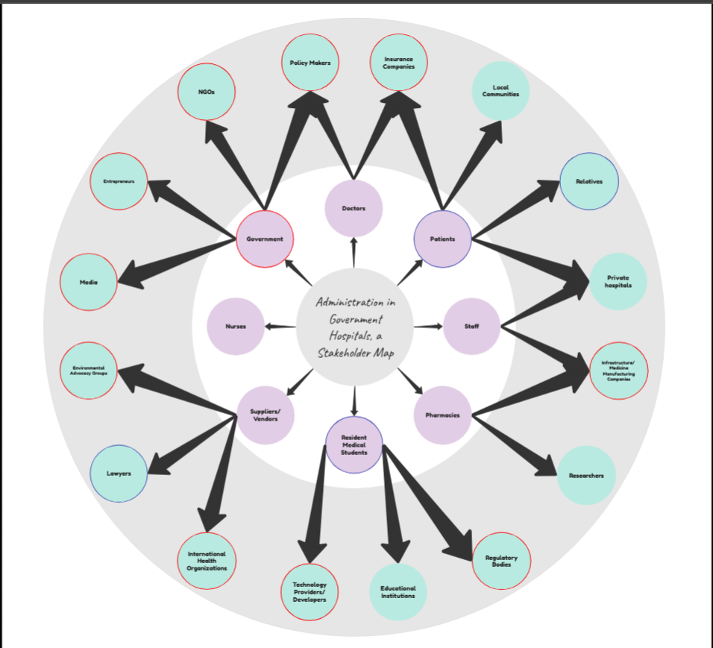

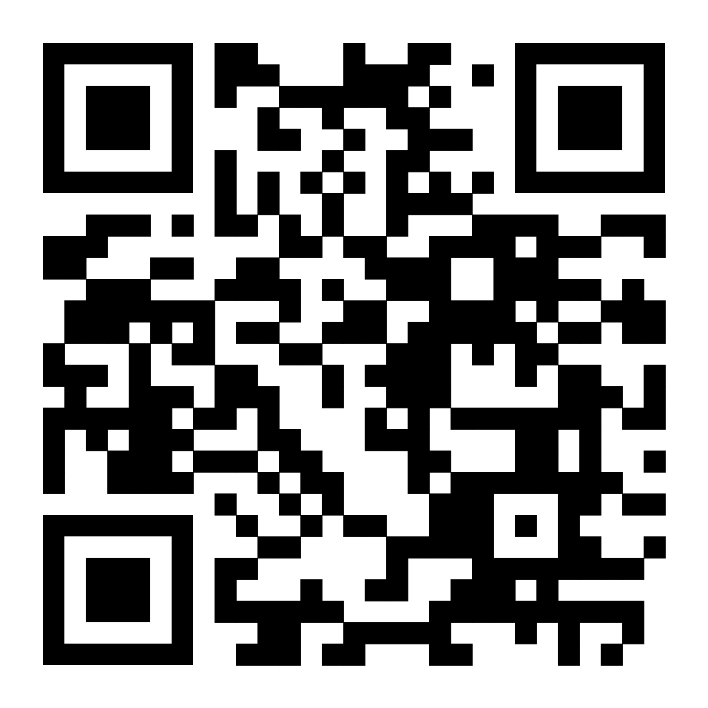

# Why Web

## Description and elaboration

1. **Efficiency**: The efficiency of processes occurring in government hospitals is very low, which results in extremely poor overall time management. The identified reasons for this appear to be a lack of appropriate technology, bureaucratic inefficiency, lack of staff, inadequate staff training, corruption, *lack of communication*, *poor management*, *lack of maintenance*, excessive overcrowding, and *lack of resources*.
2. **Management**: The overall management of government hospitals is very poor. This is the result of a *lack of resources*, bureaucratic inefficiency, *infrastructure*, technology, staff, inadequate training, excessive overcrowding, corruption, lack of proper channels, and lack of supervision.
3. **Maintenance**: The already existing infrastructure and constructed buildings have been maintained very poorly. This is because of a lack of supervision, poor engineering, inadequate training, lack of staff, lack of incentives, bureaucratic inefficiency, *lack of resources*, *lack of efficient management*, lack of apt technology, and excessive overcrowding.
4. **Hygiene**: The premises of the hospitals, and the equipment used for conducting processes in the hospitals were extremely unhygienic. According to our research, the reason for this is because of a lack of technology, *poor maintenance*, *inefficient management*, excessive overcrowding, the presence of cultural/religious/social factors, inefficient waste management, bureaucratic inefficiency, lack of staff, lack of education and awareness, and inadequate training of staff.
5. **Infrastructure**: There is a lack of apt infrastructure in government hospitals, leading to an extremely narrow range of possible healthcare facilities. This is because of a lack of funding, bureaucratic inefficiency, poor engineering, lack of staff, inadequate training of staff, lack of technology, *lack of resources*, *inefficient management*, lack of education and awareness, and lack of accountability.
6. **Communication**: There are a lot of instances of miscommunication or absence of any communication between the patients and staff or the administration and staff of government hospitals. The reasons for this are a lack of proper channels, *lack of resources*, lack of technology, presence of language barriers, lack of education and awareness, lack of staff, inadequate training of staff, excessive overcrowding, lack of supervision, and presence of cultural/religious/social factors.
7. **Safety**: A lot of our interviewees expressed concerns regarding their safety, patients and staff alike. The reasons why these concerns exist are lack of accountability, presence of language barriers, lack of proper channels, lack of technology, *lack of resources*, *inefficiency*, *lack of hygiene*, lack of education and awareness, *lack of communication*, and *lack of infrastructure*.
8. **Resources**: There is a lack of resources in government hospitals which becomes painfully obvious during times of crises like COVID-19, etc. This is caused because of a lack of technology, *lack of efficiency in administration*, bureaucratic inefficiency, excessive overcrowding, lack of funding, *lack of infrastructure*, lack of staff, inadequate training of staff, presence of cultural/religious/social factors, and privatization of healthcare.

## Root Cause Analysis

We identified the root causes to be:

1. Lack of Technology
2. Corruption
3. Bureaucratic Inefficiency
4. Lack of Education and Awareness
5. Cultural/Religious/Social Factors
6. Poor Engineering
7. Lack of Funding

## The Map

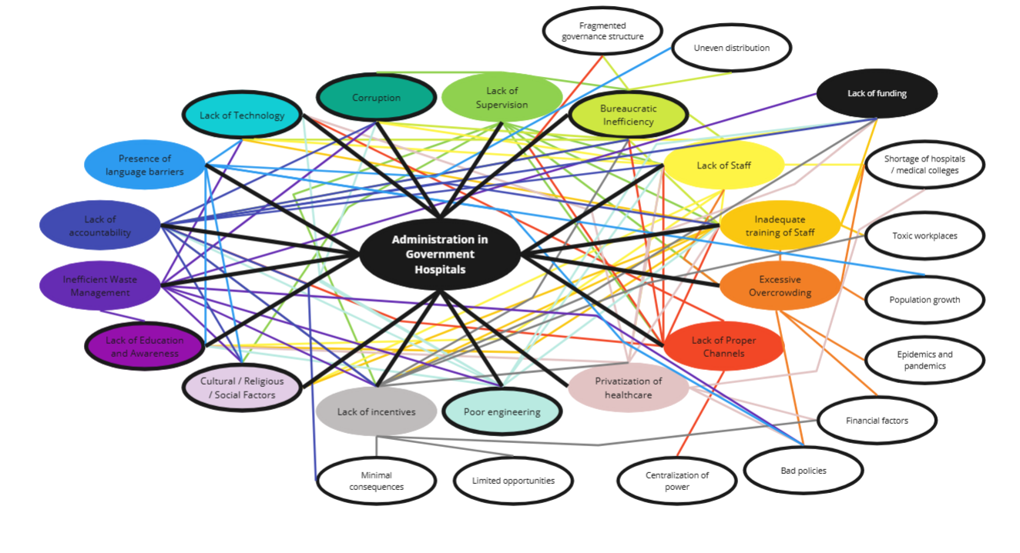



# Empathy Map

## Description and Elaboration

1. **Think:**

This section represents the thought process of hospital staff, including doctors, nurses, and administrative personnel. Their primary concerns revolve around:

Responsibilities: Managing hospital resources, improving efficiency, and managing financial constraints.

Spreading Awareness: Educating patients about healthcare services, preventive measures, and hospital procedures.

Workforce Management: Ensuring that there is enough staff to handle patient care effectively.

Emergency Preparedness: Being ready to respond to critical medical situations with limited resources.

Hospital staff are constantly under pressure to balance these responsibilities while ensuring quality care for patients.

1. **See:**

This section highlights the observations of hospital staff in their daily work environment. They witness:

Overcrowded wards, where space is insufficient for the number of patients seeking treatment.

Unfortunate deaths, which can be emotionally distressing, especially when preventable.

Inefficiency in hospital management, leading to delays in treatment and administrative bottlenecks.

Efforts and Successes: Staff recognize their hard work and moments of success despite challenges.

Failures: Despite their dedication, limitations in resources and infrastructure often lead to unavoidable failures.

The visual reality of government hospitals is a mix of hardships and triumphs, but the inefficiencies often overshadow the victories.

1. **Feel:**

The emotional state of hospital staff is a crucial aspect of the empathy map. They often experience:

Overwhelmed feelings due to excessive responsibilities and high-pressure situations.

Frustration from system inefficiencies, bureaucracy, and resource shortages.

Insecurity/Incapability when they are unable to provide the best care due to limitations beyond their control.

Underappreciation, as their hard work is often unnoticed or overshadowed by negative feedback.

Trauma from witnessing deaths, especially preventable ones due to lack of resources or mismanagement.

These emotions directly impact their mental health and job performance, making it essential to address their concerns.

1. **Hear:**

This section represents what hospital staff frequently listen to in their work environment:

Complaints from patients and their families about delays, lack of proper care, or insufficient facilities.

Grievances from colleagues, who may express frustration over poor working conditions or unmanageable workloads.

Suggestions and Feedback from patients and other hospital workers on ways to improve services.

Orders from Authorities & Higher-Ups, dictating policies, budget constraints, and operational decisions.

Criticism, often directed at the hospital for its inefficiencies, long wait times, and lack of resources.

The constant stream of negative feedback and grand expectations from the public and administration make it challenging for staff to stay motivated.

1. **Do:**

This section outlines the actions hospital staff take daily to keep the system running. Their responsibilities include:

Managing Resources: Allocating beds, medical supplies, and essential equipment to accommodate patients.

Coordinating Staff & Communication: Ensuring doctors, nurses, and administrative teams work together effectively.

Solving Problems: Addressing issues like patient overload, emergency cases, and supply shortages.

Treating Patients: Providing medical care, monitoring recovery, and ensuring patient well-being.

Documentation: Keeping records of patient history, treatment plans, and administrative data.

Despite these efforts, the lack of a streamlined system makes their tasks overwhelming, often resulting in burnout.

1. **Say:**

This section reflects what hospital staff express publicly about their situation:

Voicing concerns and opinions about hospital conditions, staff shortages, and management inefficiencies.

Aspirations and hope for better healthcare infrastructure, improved policies, and digital solutions that can make their work easier.

Despite their challenges, hospital staff continue to express their desire for change and progress in public healthcare systems.

1. **Pains:**

The biggest challenges faced by government hospital staff include:

Limited Budget: Insufficient funds to improve facilities, hire staff, and upgrade equipment.

Staff Shortage: A lack of doctors, nurses, and administrative personnel leading to an overworked workforce.

Overcrowding: Too many patients seeking treatment, resulting in long waiting times and strained resources.

Poor Maintenance: Lack of hygiene, faulty equipment, and improper waste disposal.

Lack of Navigation: Patients struggling to find the right departments, leading to confusion and inefficiency.

These pain points highlight the need for systemic improvements and better resource allocation.

1. **Gains:**

Despite the challenges, implementing effective solutions could bring several benefits, including:

Better Resources: Increased funding, improved facilities, and upgraded medical equipment.

Higher Satisfaction Levels: More efficient hospital management leading to better patient and staff experiences.

Public Trust: A well-managed system would boost public confidence in government hospitals.

By addressing the problems identified, government hospitals can transform into efficient, patient-friendly institutions that deliver high-quality care.

## The Map



# How might we?

Our “how might we” statements are as follows:

1. How might we design apt technology for the staff and patients of government hospitals, to make the administration and management processes more efficient?
2. How might we educate and increase awareness for the staff in government hospitals, so that we can introduce proper channels of communications and ensure safety?
3. How might we increase funds for the staff of government hospitals, so that there is an improvement in the management and hygiene, and there is an apt distribution of resources?
4. How might we create an efficient waste management system for the patients and staff of government hospitals so that healthcare processes are more hygienic and eventually a broader range of treatment is developed?

# Ideation

## Our ideas

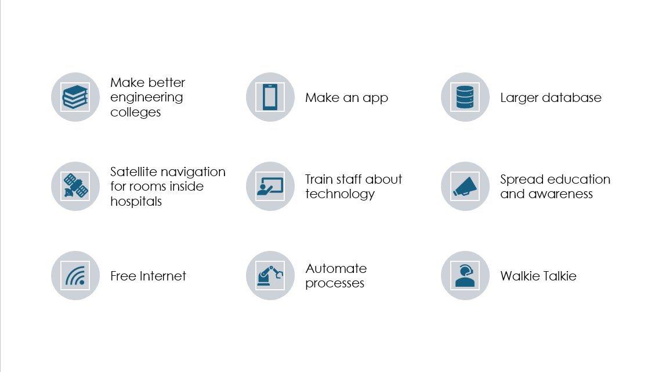

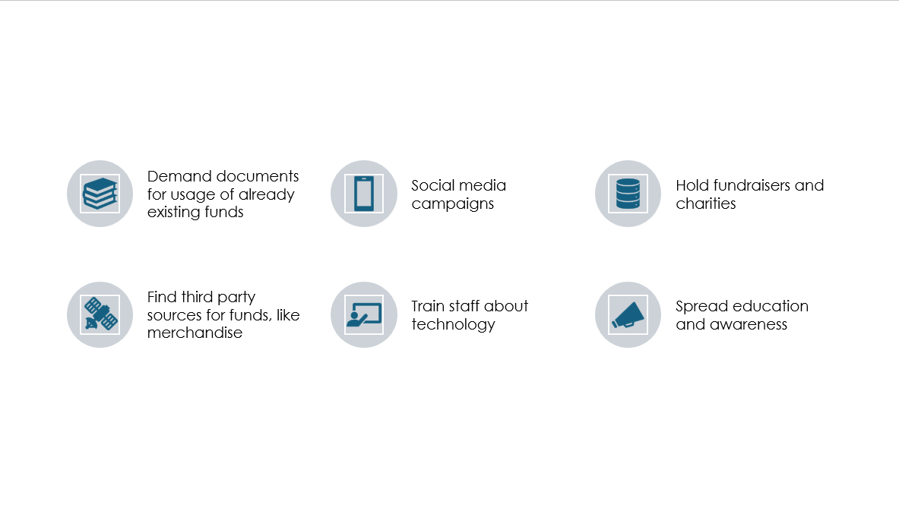

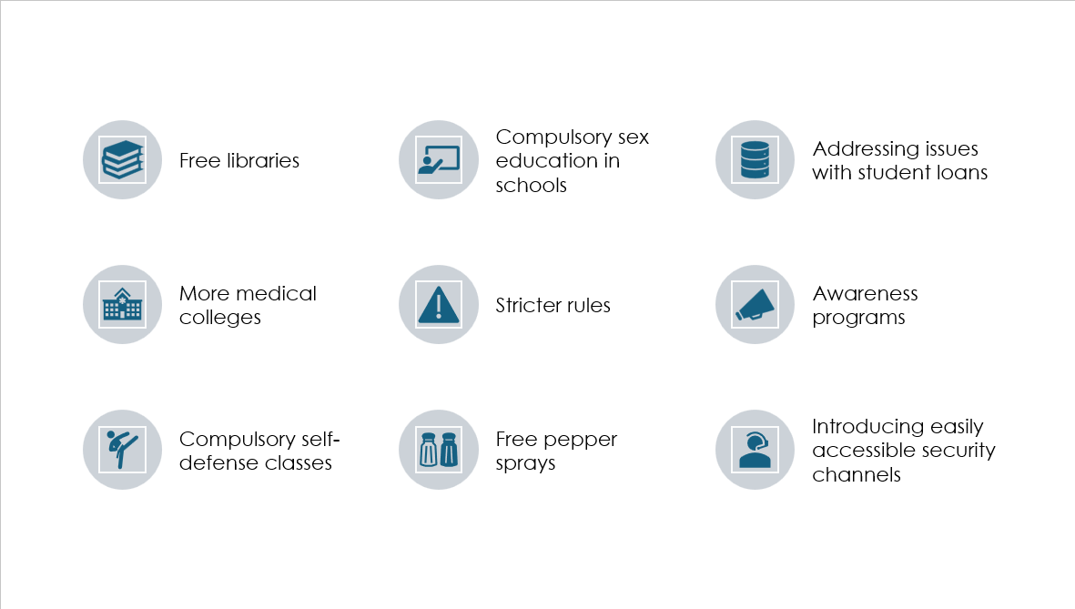

## DVF Analysis of our solutions

1. **Using nanomaterials for hospital clothes:**

Our idea of using nanomaterials for government hospital cloth is strong in terms of desirability, viability, and feasibility:

Desirability: Hospitals require hygienic and easy-to-maintain clothing for staff, patients, and bedding. Dirt-resistant and self-cleaning fabrics would reduce contamination risks, enhance hygiene, and improve the hospital experience.

Viability: The healthcare sector is willing to invest in solutions that reduce maintenance costs and improve hygiene. If your nanomaterial reduces laundry expenses and extends fabric lifespan, it can be financially sustainable.

Feasibility: Advances in nanotechnology have already enabled dirt-resistant and self-cleaning fabrics using coatings like silica, titanium dioxide, or graphene-based materials. With the right research and manufacturing, implementing this at scale is achievable.

1. **Creating a robot:**

Our idea of a robot for collecting hospital waste door-to-door is strong in terms of desirability, viability, and feasibility:

Desirability: Government hospitals generate large amounts of biomedical and general waste. A robotic system would reduce human exposure to infectious waste, improve hygiene, and streamline waste management.

Viability: Hospitals already invest in waste management, but manual collection poses health risks and inefficiencies. A robot could lower labour costs, reduce infection risks, and ensure timely waste disposal, making it a valuable investment.

Feasibility: Autonomous robots with AI and navigation systems already exist in industries like logistics and cleaning. Implementing similar technology for waste collection in hospitals is technically achievable with proper design and funding.

1. **Creating an app:**

Our idea of an app for government hospitals strong in terms of desirability, viability, and feasibility:

Desirability: Government hospitals often face issues with record-keeping, long queues, and mismanagement of patient data. A digital system would improve efficiency, reduce paperwork, and enhance patient care.

Viability: The government is pushing for digital healthcare initiatives. If our app integrates with existing systems and offers secure, efficient record-keeping, it can be widely adopted and funded.

Feasibility: Cloud-based hospital management systems are already in use. With proper cybersecurity measures and government collaboration, developing and deploying such an app is practical and achievable.

# Prototype

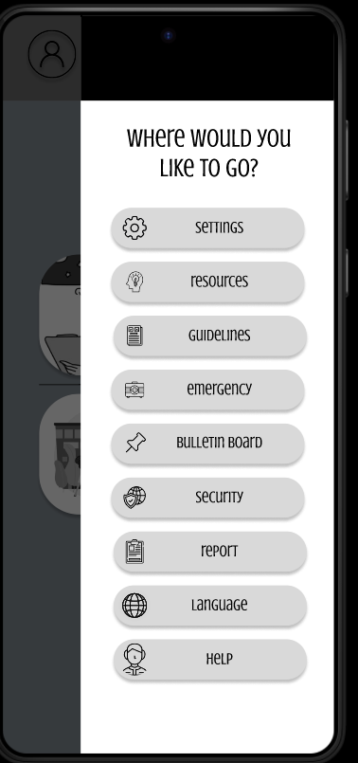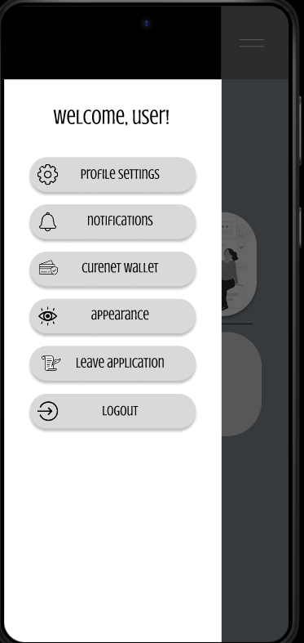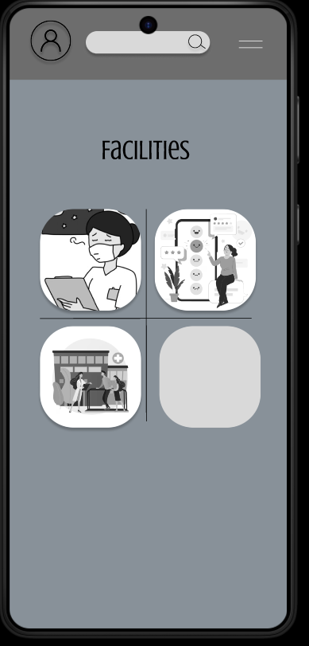

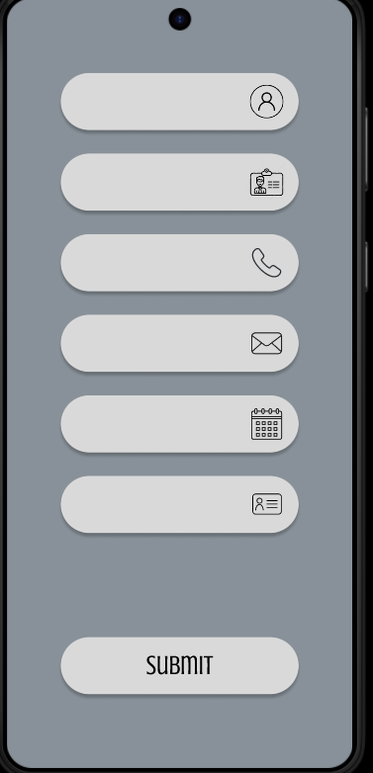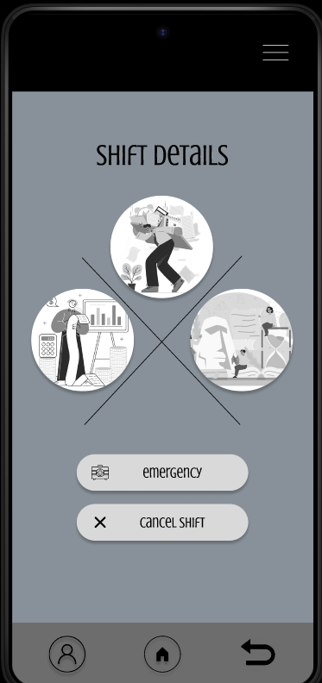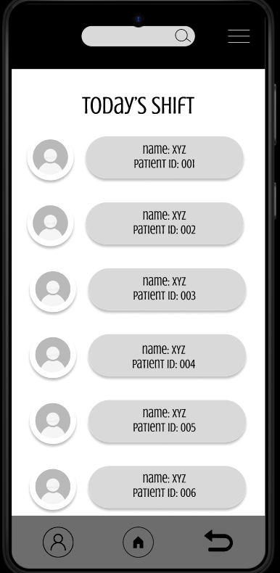



# Testing

To test our prototype, we can proceed with the following steps:

1. Test the app with a small internal team of developers or a small internal team to detect bugs, glitches, and usability problems. Ensure all basic features (patient records, doctor scheduling, etc.) work smoothly.
2. Collaborate with a small government hospital or a department of a hospital for real-world testing. Train doctors, nurses, and administrative staff to operate the app and get feedback on usability and efficiency.
3. Implement the app in one or two government hospitals for a pilot run. Monitor its performance in real-time, checking for errors in data management, server load, and user experience.
4. Collect feedback from hospital staff and patients through surveys and interviews. Resolve any problems and enhance features based on user feedback.
5. Following rules and regulations according to national health agency security audits to ensure protection of sensitive patient data.
6. After successful testing, approach government health departments for official implementation.
7. Gradually roll out to more hospitals and integrate with existing health systems.

# Work log

|  |  |
| --- | --- |
|  |  |
| Primary Research | Bushra, Bibhash, Dattatreya, Chetan, Chiran, Vijay |
| Secondary Research | Bushra, Dattatreya |
| Problem Identification | Bushra, Bibhash, Dattatreya, Chetan, Chiran, Vijay |
| Ideation | Bushra, Bibhash, Dattatreya, Chetan, Chiran, Vijay |
| Prototype | Dattatreya, Bibhash |

# References

1. <https://www.hindustantimes.com/cities/delhi-news/patients-say-facing-years-long-wait-at-delhi-govt-hospitals-for-routine-tests-101675683027296.html>
2. <https://timesofindia.indiatimes.com/city/kolkata/refusal-to-admission-long-wait-for-check-ups-as-patient-rush-continues-at-govt-hospitals/articleshow/113646252.cms>
3. <https://www.tribuneindia.com/news/patiala/long-queues-of-patients-at-govt-hospital-commonplace-409799/>
4. <https://english.mathrubhumi.com/news/kerala/hospital-staff-suspended-for-allegedly-attempting-to-physically-abuse-a-patient-1.8886170>
5. <https://timesofindia.indiatimes.com/city/coimbatore/inquiry-launched-against-doctor-for-refusing-to-examine-murder-accused-in-salem/articleshow/115152072.cms>
6. <https://youtu.be/koigBJkDDuY?si=HkP50VEEUo1Esgbw>
7. <https://youtu.be/HXpkDB1xd2A?si=8sPiVIvPl8na-CDV>